Chapter 16
Financial Distress, Managerial Incentives, and Information

16-1. Gladstone Corporation is about to launch a new product. Depending on the success of the new product, Gladstone may have one of four values next year: $150 million, $135 million, $95 million, or $80 million. These outcomes are all equally likely, and this risk is diversifiable. Gladstone will not make any payouts to investors during the year. Suppose the risk-free interest rate is 5% and assume perfect capital markets.
a. What is the initial value of Gladstone’s equity without leverage?
Now suppose Gladstone has zero-coupon debt with a $100 million face value due next year.
b. What is the initial value of Gladstone’s debt?
c. What is the yield-to-maturity of the debt? What is its expected return?
d. What is the initial value of Gladstone’s equity? What is Gladstone’s total value with leverage?
a. 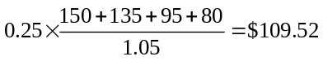 million
b. 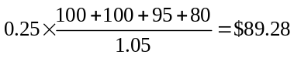 million
c. YTM = 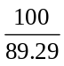 – 1= 12%
expected return = 5%
d. equity = 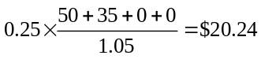 million total value = 89.28 +20.24 = $109.52 million
16-2. Baruk Industries has no cash and a debt obligation of $36 million that is now due. The market value of Baruk’s assets is $81 million, and the firm has no other liabilities. Assume perfect capital markets.
a. Suppose Baruk has 10 million shares outstanding. What is Baruk’s current share price?
b. How many new shares must Baruk issue to raise the capital needed to pay its debt obligation?
c. After repaying the debt, what will Baruk’s share price be?
a. 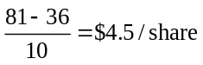
b. 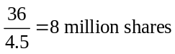
c. 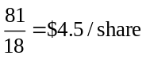
16-3. When a firm defaults on its debt, debt holders often receive less than 50% of the amount they are owed. Is the difference between the amount debt holders are owed and the amount they receive a cost of bankruptcy?
No. Some of these losses are due to declines in the value of the assets that would have occurred whether or not the firm defaulted. Only the incremental losses that arise from the bankruptcy process are bankruptcy costs.
16-4. Which type of firm is more likely to experience a loss of customers in the event of financial distress:
a. Campbell Soup Company or Intuit, Inc. (a maker of accounting software)?
b. Allstate Corporation (an insurance company) or Adidas AG (maker of athletic footwear, apparel, and sports equipment)?
a. Intuit Inc.—its customers will care about their ability to receive upgrades to their software.
b. Allstate Corporation—its customers rely on the firm being able to pay future claims.
16-5. Which type of asset is more likely to be liquidated for close to its full market value in the event of financial distress:
a. An office building or a brand name?
b. Product inventory or raw materials?
c. Patent rights or engineering “know-how”?
a. Office building—there are many alternate users who would be likely to value the property similarly.
b. Raw materials—they are easier to reuse.
c. Patent rights—they would be easier to sell to another firm.
16-6. Suppose Tefco Corp. has a value of $100 million if it continues to operate, but has outstanding debt of $120 million that is now due. If the firm declares bankruptcy, bankruptcy costs will equal $20 million, and the remaining $80 million will go to creditors. Instead of declaring bankruptcy, management proposes to exchange the firm’s debt for a fraction of its equity in a workout. What is the minimum fraction of the firm’s equity that management would need to offer to creditors for the workout to be successful?
Creditors receive 80 million in bankruptcy, so they need to receive at least this much. Therefore, Tefco could offer its creditors 80% of the firm in a workout.
16-7. You have received two job offers. Firm A offers to pay you $85,000 per year for two years. Firm B offers to pay you $90,000 for two years. Both jobs are equivalent. Suppose that firm A’s contract is certain, but that firm B has a 50% chance of going bankrupt at the end of the year. In that event, it will cancel your contract and pay you the lowest amount possible for you to not quit. If you did quit, you expect you could find a new job paying $85,000 per year, but you would be unemployed for 3 months while you search for it.
a. Say you took the job at firm B. What is the least firm B can pay you next year in order to match what you would earn if you quit?
b. Given your answer to part (b), and assuming your cost of capital is 5%, which offer pays you a higher present value of your expected wage?
c. Based on this example, discuss one reason why firms with a higher risk of bankruptcy may need to offer higher wages to attract employees.
a. If you quit, you would earn $85k for ¾ of a year, or $63.75k.
b. A = 85 + 85/1.05 = $165.95k
B = 90 + ½ (90 + 63.75)/1.05 = $163.21 k
c. The risk of bankruptcy decreases the expected wage an employee is set to receive, therefore the firm must pay a higher wage to incentivize the employee not to quit
16-8. As in Problem 1, Gladstone Corporation is about to launch a new product. Depending on the success of the new product, Gladstone may have one of four values next year: $150 million, $135 million, $95 million, or $80 million. These outcomes are all equally likely, and this risk is diversifiable. Suppose the risk-free interest rate is 5% and that, in the event of default, 25% of the value of Gladstone’s assets will be lost to bankruptcy costs. (Ignore all other market imperfections, such as taxes.)
a. What is the initial value of Gladstone’s equity without leverage?
Now suppose Gladstone has zero-coupon debt with a $100 million face value due next year.
b. What is the initial value of Gladstone’s debt?
c. What is the yield-to-maturity of the debt? What is its expected return?
d. What is the initial value of Gladstone’s equity? What is Gladstone’s total value with leverage?
Suppose Gladstone has 10 million shares outstanding and no debt at the start of the year.
e. If Gladstone does not issue debt, what is its share price?
f. If Gladstone issues debt of $100 million due next year and uses the proceeds to repurchase shares, what will its share price be? Why does your answer differ from that in part (e)?
a. million
b. 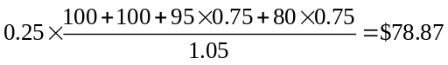 million
c. 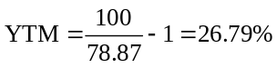
expected return = 5%
d. 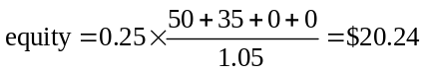 million total value 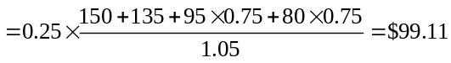 million
(or 78.87 + 20.24 = $99.11 million)
e. 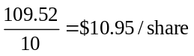
f. 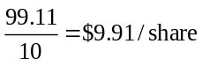 Bankruptcy cost lowers share price.
Note that Gladstone will raise $78.87 million from the debt, and repurchase 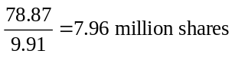. Its equity will be worth $20.24 million, for a share price of 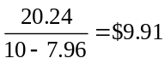 after the transaction is completed.
16-9. Kohwe Corporation plans to issue equity to raise $50 million to finance a new investment. After making the investment, Kohwe expects to earn free cash flows of $10 million each year. Kohwe currently has 5 million shares outstanding, and it has no other assets or opportunities. Suppose the appropriate discount rate for Kohwe’s future free cash flows is 8%, and the only capital market imperfections are corporate taxes and financial distress costs.
a. What is the NPV of Kohwe’s investment?
b. What is Kohwe’s share price today?
Suppose Kohwe borrows the $50 million instead. The firm will pay interest only on this loan each year, and it will maintain an outstanding balance of $50 million on the loan. Suppose that Kohwe’s corporate tax rate is 40%, and expected free cash flows are still $10 million each year.
c. What is Kohwe’s share price today if the investment is financed with debt?
Now suppose that with leverage, Kohwe’s expected free cash flows will decline to $9 million per year due to reduced sales and other financial distress costs. Assume that the appropriate discount rate for Kohwe’s future free cash flows is still 8%.
d. What is Kohwe’s share price today given the financial distress costs of leverage?
a. 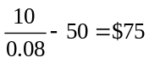 million
b. 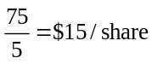
c. 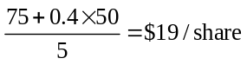
d. 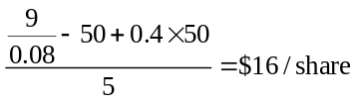
16-10. You work for a large car manufacturer that is currently financially healthy. Your manager feels that the firm should take on more debt because it can thereby reduce the expense of car warranties. To quote your manager, “If we go bankrupt, we don’t have to service the warranties. We therefore have lower bankruptcy costs than most corporations, so we should use more debt.” Is he right?
No, not necessarily. He has neglected the effect on customers. Customers will be less willing to buy the company’s cars because the warranty is not as solid as the company’s competitors. Since the warranty is presumably offered to entice customers to buy more cars, the overall effect could easily be to reduce value.
16-11. Apple Computer has no debt. As Problem 21 in Chapter 15 makes clear, by issuing debt Apple can generate a very large tax shield potentially worth over $10 billion. Given Apple’s success, one would be hard pressed to argue that Apple’s management are naïve and unaware of this huge potential to create value. A more likely explanation is that issuing debt would entail other costs. What might these costs be?
Apple has volatile cash flows, a high beta (around 2), and is a human-capital intensive firm. All of these things imply that Apple has relatively high distress costs.
16-12. Hawar International is a shipping firm with a current share price of $5.50 and 10 million shares outstanding. Suppose Hawar announces plans to lower its corporate taxes by borrowing $20 million and repurchasing shares.
a. With perfect capital markets, what will the share price be after this announcement?
Suppose that Hawar pays a corporate tax rate of 30%, and that shareholders expect the change in debt to be permanent.
b. If the only imperfection is corporate taxes, what will the share price be after this announcement?
c. Suppose the only imperfections are corporate taxes and financial distress costs. If the share price rises to $5.75 after this announcement, what is the PV of financial distress costs Hawar will incur as the result of this new debt?
a. The same price, $5.50/share, because financial transactions do not create value.
b. 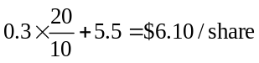
c. (6.1 – 5.75) × 10 = $3.5 million
16-13. Your firm is considering issuing one-year debt, and has come up with the following estimates of the value of the interest tax shield and the probability of distress for different levels of debt:
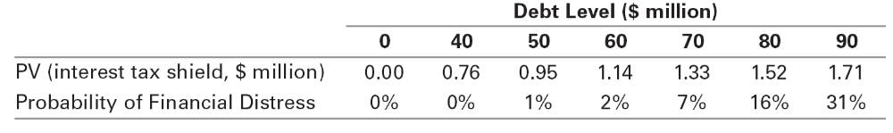
Suppose the firm has a beta of zero, so that the appropriate discount rate for financial distress costs is the risk-free rate of 5%. Which level of debt above is optimal if, in the event of distress, the firm will have distress costs equal to
a. $2 million?
b. $5 million?
c. $25 million?
a. 80
b. 60
c. 40
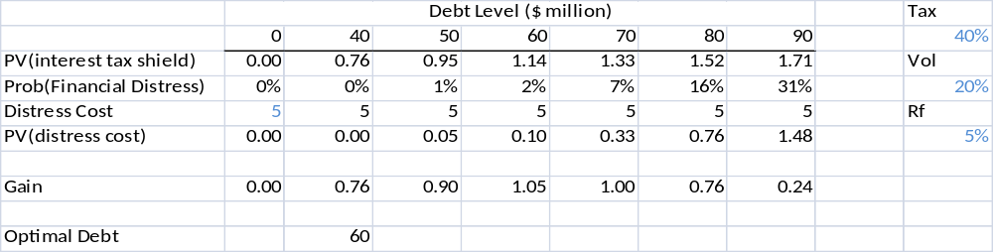
16-14. Marpor Industries has no debt and expects to generate free cash flows of $16 million each year. Marpor believes that if it permanently increases its level of debt to $40 million, the risk of financial distress may cause it to lose some customers and receive less favorable terms from its suppliers. As a result, Marpor’s expected free cash flows with debt will be only $15 million per year. Suppose Marpor’s tax rate is 35%, the risk-free rate is 5%, the expected return of the market is 15%, and the beta of Marpor’s free cash flows is 1.10 (with or without leverage).
a. Estimate Marpor’s value without leverage.
b. Estimate Marpor’s value with the new leverage.
a. r = 5% + 1.1 × (15% – 5%) = 16%
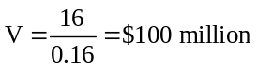
b. r = 5% + 1.1 × (15% – 5%) = 16%
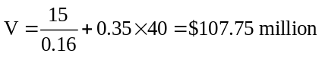
16-15. Real estate purchases are often financed with at least 80% debt. Most corporations, however, have less than 50% debt financing. Provide an explanation for this difference using the tradeoff theory.
According to tradeoff theory, a tax shield adds value while financial distress costs reduce a firm’s value. The financial distress costs for a real estate investment are likely to be low, because the property can generally be easily resold for its full market value. In contrast, corporations generally face much higher costs of financial distress. As a result, corporations choose to have lower leverage.
16-16. On May 14, 2008, General Motors paid a dividend of $0.25 per share. During the same quarter GM lost a staggering $15.5 billion or $27.33 per share. Seven months later the company asked for billions of dollars of government aid and ultimately declared bankruptcy just over a year later, on June 1, 2009. At that point a share of GM was worth only a little more than a dollar.
a. If you ignore the possibility of a government bailout, the decision to pay a dividend given how close the company was to financial distress is an example of what kind of cost?
b. What would your answer be if GM executives anticipated that there was a possibility of a government bailout should the firm be forced to declare bankruptcy?
a. Agency cost—cashing out
b. By paying a dividend, executives increased the probability of bankruptcy and therefore the probability of receiving government funds. Since these government funds are funds that investors would not otherwise be entitled to, the payment of a dividend could actually raise firm value in this case.
16-17. Dynron Corporation’s primary business is natural gas transportation using its vast gas pipeline network. Dynron’s assets currently have a market value of $150 million. The firm is exploring the possibility of raising $50 million by selling part of its pipeline network and investing the $50 million in a fiber-optic network to generate revenues by selling high-speed network bandwidth. While this new investment is expected to increase profits, it will also substantially increase Dynron’s risk. If Dynron is levered, would this investment be more or less attractive to equity holders than if Dynron had no debt?
If Dynron has no debt or if in all scenarios Dynron can pay the debt in full, equity holders will only consider the project’s NPV in making the decision. If Dynron is heavily leveraged, equity holders will also gain from the increased risk of the new investment.
16-18. Consider a firm whose only asset is a plot of vacant land, and whose only liability is debt of $15 million due in one year. If left vacant, the land will be worth $10 million in one year. Alternatively, the firm can develop the land at an upfront cost of $20 million. The developed land will be worth $35 million in one year. Suppose the risk-free interest rate is 10%, assume all cash flows are risk-free, and assume there are no taxes.
a. If the firm chooses not to develop the land, what is the value of the firm’s equity today? What is the value of the debt today?
b. What is the NPV of developing the land?
c. Suppose the firm raises $20 million from equity holders to develop the land. If the firm develops the land, what is the value of the firm’s equity today? What is the value of the firm’s debt today?
d. Given your answer to part (c), would equity holders be willing to provide the $20 million needed to develop the land?
a. equity = 0
debt = 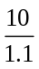 = $9.09 million
b. NPV =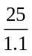 – 20 = $2.73 million
c. debt = 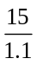 = $13.64 million
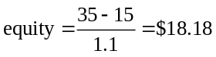 million
d. Equity holders will not be willing to accept the deal, because for them it is a negative NPV investment (18.18 – 20 < 0).
16-19. Sarvon Systems has a debt-equity ratio of 1.2, an equity beta of 2.0, and a debt beta of 0.30. It currently is evaluating the following projects, none of which would change the firm’s volatility (amounts in $ million):
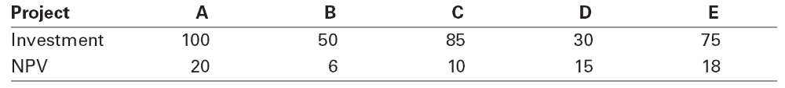
a. Which project will equity holders agree to fund?
b. What is the cost to the firm of the debt overhang?
a. A + D + E
b. Don’t take B&C = loss of 6 + 10 = 16 million
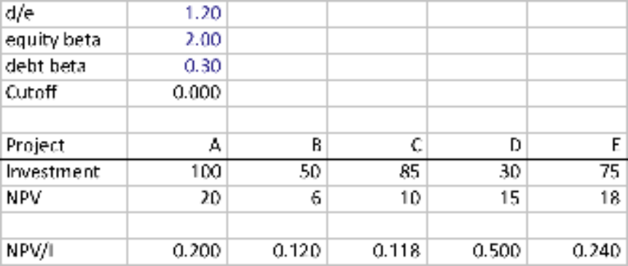
16-20. Zymase is a biotechnology start-up firm. Researchers at Zymase must choose one of three different research strategies. The payoffs (after-tax) and their likelihood for each strategy are shown below. The risk of each project is diversifiable.
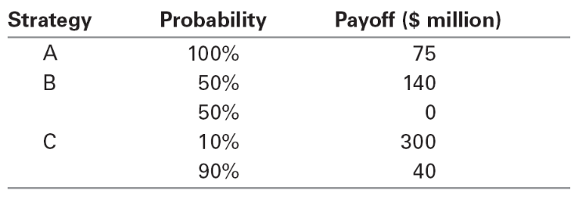
a. Which project has the highest expected payoff?
b. Suppose Zymase has debt of $40 million due at the time of the project’s payoff. Which project has the highest expected payoff for equity holders?
c. Suppose Zymase has debt of $110 million due at the time of the project’s payoff. Which project has the highest expected payoff for equity holders?
d. If management chooses the strategy that maximizes the payoff to equity holders, what is the expected agency cost to the firm from having $40 million in debt due? What is the expected agency cost to the firm from having $110 million in debt due?
a. E(A) = $75 million
E(B) = 0.5 × 140 = $70 million
E(C) = 0.1 × 300 + 0.9 × 40 = $66 million
Project A has the highest expected payoff.
b. E(A) = 75 – 40 = $35 million
E(B) = 0.5 × (140 – 40) = $50 million
E(C) = 0.1 × (300 – 40) + 0.9 × (40 – 40) = $26 million
Project B has the highest expected payoff for equity holders.
c. E(A) =$0 million
E(B) = 0.5 × (140 – 110) = $15 million
E(C) = 0.1 × (300 – 110) = $19 million
Project C has the highest expected payoff for equity holders.
d. With $40 million in debt, management will choose project B, which has an expected payoff for the firm that is 75 – 70 = $5 million less than project A. Thus, the expected agency cost is $5 million.
With $110 million in debt, management will choose project C, resulting in an expected agency cost of 75 – 66 = $9 million.
16-21. Petron Corporation’s management team is meeting to decide on a new corporate strategy. There are four options, each with a different probability of success and total firm value in the event of success, as shown below:
 | Strategy
 | A | B | C | D
Probability of Success | 100% | 80% | 60% | 40%
Firm Value if Successful (in $ million) | 50 | 60 | 70 | 80
Assume that for each strategy, firm value is zero in the event of failure.
a. Which strategy has the highest expected payoff?
b. Suppose Petron’s management team will choose the strategy that leads to the highest expected value of Petron’s equity. Which strategy will management choose if Petron currently has
(i) No debt?
(ii) Debt with a face value of $20 million?
(iii) Debt with a face value of $40 million?
c. What agency cost of debt is illustrated in your answer to part (b)?
a, b.
 | A | B | C | D
Expected Payoff (p*V) | 50 | 48 | 42 | 32
 | Equity Value = p*(V – D)
Debt Face Value (D) | A | B | C | D
0 | 50 | 48 | 42 | 32
20 | 30 | 32 | 30 | 24
40 | 10 | 16 | 18 | 16
Thus, the firm will choose strategy A when D = 0, B when D = 20, and C when D = 40.
c. This result illustrates the agency cost of excessive risk taking with leverage. As the amount of leverage increases, the firm’s equity holders prefer that the firm adopt riskier strategies, even though these riskier strategies lower the total value of the firm.
16-22. Consider the setting of Problem 21, and suppose Petron Corp. has debt with a face value of $40 million outstanding. For simplicity, assume all risk is idiosyncratic, the risk-free interest rate is zero, and there are no taxes.
a. What is the expected value of equity, assuming Petron will choose the strategy that maximizes the value of its equity? What is the total expected value of the firm?
b. Suppose Petron issues equity and buys back its debt, reducing the debt’s face value to $5 million. If it does so, what strategy will it choose after the transaction? Will the total value of the firm increase?
c. Suppose you are a debt holder, deciding whether to sell your debt back to the firm. If you expect the firm to reduce its debt to $5 million, what price would you demand to sell your debt?
d. Based on your answer to (c), how much will Petron need to raise from equity holders in order to buy back the debt?
e. How much will equity holders gain or lose by recapitalizing to reduce leverage? How much will debt holders gain or lose? Would you expect Petron’s management to choose to reduce its leverage?
a. With $40 million face value of debt, the firm will choose strategy C. Thus, the expected value of the firm is $42 million and the expected value of equity is $18 million.
b. With $5 million in debt outstanding, management will choose strategy A:
 | Equity Value = p*(V – D)
Debt Face Value (D) | A | B | C | D
5 | 45 | 44 | 39 | 30
c. After the transaction, the debt will be risk free. Price will thus be face value.
d. Petron will need to raise $35 million from equity holders (as the debt is risk free and has a face value of $35 million).
e. The expected value of equity after the transaction is $45 million, but equity holders had to contribute $35 million to buy back the debt. Thus, the net expected payoff to equity holders is $10 million. If they had not done the buyback, equity would have been worth $18 million. Thus, equity holders lost $8 million as a result of the buyback.
Debt holders received $35 million, and still hold $5 million in risk-free debt, for a total payoff of $40 million after the buyback. Had Petron not done the buyback, the debt would have been worth 60% × $40m = $24 million. Thus, debt holders gained $16 million as a result of the buyback.
As we can see, even though the total value of the firm increases by $8 million by reducing leverage and eliminating agency costs, the debt holders capture more than $8 million, and thus equity holders lose. Therefore, even though Petron has an inefficiently high level of leverage, the ratchet effect of debt overhang implies that it will not choose to reduce its leverage.

16-23. Consider the setting of Problems 21 and 22, and suppose Petron Corp. must pay a 25% tax rate on the amount of the final payoff that is paid to equity holders. It pays no tax on payments to, or capital raised from, debt holders.
a. Which strategy will Petron choose with no debt? Which will it choose with a face value of $10 million, $30 million, or $50 million in debt? (Assume management maximizes the value of equity, and in the case of ties, will choose the safer strategy.)
b. Given your answer to (a), show that the total combined value of Petron’s equity and debt is maximized with a face value of $30 million in debt.
c. Show that if Petron has $30 million in debt outstanding, shareholders can gain by increasing the face value of debt to $50 million, even though this will reduce the total value of the firm.
d. Show that if Petron has $50 million in debt outstanding, shareholders will lose by buying back debt to reduce the face value of debt to $30 million, even though that will increase the total value of the firm.
a. The table shows value of equity for different debt levels and strategy choices. Optimal strategies are highlighted:
 | Equity Value = p × (1-t) × (V – D)
Debt Face Value (D) | A | B | C | D
0 | 37.5 | 36 | 31.5 | 24
10 | 30 | 30 | 27 | 21
20 | 22.5 | 24 | 22.5 | 18
30 | 15 | 18 | 18 | 15
40 | 7.5 | 12 | 13.5 | 12
50 | 0 | 6 | 9 | 9
Thus, the firm will choose strategy A for debt = 0, 10, strategy B for D = 30, and Strategy C for D = 50.
b. The total value of the firm in each case is:
Debt Face Value | 10 | 30 | 50 | 80 | 0
Debt Value | 10 | 24 | 30 | 32 | 0
Equity Value | 30 | 18 | 9 | 0 | 37.5
Firm Value | 40 | 42 | 39 | 32 | 37.5
Firm value is maximized with a face value of $30 million debt
c. With D = 30, equity holders can raise 20 × 60% = 12 by increasing debt to 50. Thus, equity holders get 9 + 12 = 21 > 18, and equity holder gain by increasing leverage.
d. With D = 50, equity holders must invest 20 × 80% = 16 to buyback debt to a face value of 30. Thus equity holders get 18 – 16 = 2 < 9, so shareholders lose if they reduce leverage.

16-24. You own your own firm, and you want to raise $30 million to fund an expansion. Currently, you own 100% of the firm’s equity, and the firm has no debt. To raise the $30 million solely through equity, you will need to sell two-thirds of the firm. However, you would prefer to maintain at least a 50% equity stake in the firm to retain control.
a. If you borrow $20 million, what fraction of the equity will you need to sell to raise the remaining $10 million? (Assume perfect capital markets.)
b. What is the smallest amount you can borrow to raise the $30 million without giving up control? (Assume perfect capital markets.)
a. Market value of firm Assets 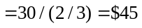 million. With debt of $20 million, equity is worth 45 – 20 = 25, so you will need to sell 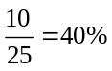 of the equity.
b. Given debt D, equity is worth 45 – D. Selling 50% of equity, together with debt must raise $30 million: 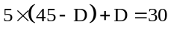. Solve for D = $15 million.
16-25. Empire Industries forecasts net income this coming year as shown below (in thousands of dollars):
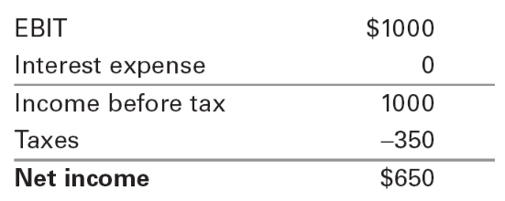
Approximately $200,000 of Empire’s earnings will be needed to make new, positive-NPV investments. Unfortunately, Empire’s managers are expected to waste 10% of its net income on needless perks, pet projects, and other expenditures that do not contribute to the firm. All remaining income will be returned to shareholders through dividends and share repurchases.
a. What are the two benefits of debt financing for Empire?
b. By how much would each $1 of interest expense reduce Empire’s dividend and share repurchases?
c. What is the increase in the total funds Empire will pay to investors for each $1 of interest expense?
a. In addition to the tax benefits of leverage, debt financing can benefit Empire by reducing wasteful investment.
b. Net income will fall by $1 × 0.65 = $0.65.
Because 10% of net income will be wasted, dividends and share repurchases will fall by $0.65 × (1 – 0.10) = $0.585.
c. Pay $1 in interest, give up $0.585 in dividends and share repurchases ⇒ Increase of 1 – 0.585 = $0.415 per $1 of interest.
16-26. Ralston Enterprises has assets that will have a market value in one year as follows:
That is, there is a 1% chance the assets will be worth $70 million, a 6% chance the assets will be worth $80 million, and so on. Suppose the CEO is contemplating a decision that will benefit her personally but will reduce the value of the firm’s assets by $10 million. The CEO is likely to proceed with this decision unless it substantially increases the firm’s risk of bankruptcy.
a. If Ralston has debt due of $75 million in one year, the CEO’s decision will increase the probability of bankruptcy by what percentage?
b. What level of debt provides the CEO with the biggest incentive not to proceed with the decision?
a. Without personal spending, there is a 1% chance of bankruptcy.
With $10 million personal spending, there is a 7% chance—so the probability of bankruptcy increased by 6%.
b. Debt between $90 and $100 million will provide the CEO with the biggest incentive not to proceed with personal spending, because by doing so the chance of bankruptcy would increase by 38%.
16-27. Although the major benefit of debt financing is easy to observe—the tax shield—many of the indirect costs of debt financing can be quite subtle and difficult to observe. Describe some of these costs.
Overinvestment: investing in negative NPV projects; underinvestment: not investing in positive NPV projects; cashing out: paying out dividends instead of investing in positive NPV projects; employee job security: highly leveraged firms run the risk of bankruptcy and so cannot write long-term employment contracts and offer job security.
16-28. If it is managed efficiently, Remel Inc. will have assets with a market value of $50 million, $100 million, or $150 million next year, with each outcome being equally likely. However, managers may engage in wasteful empire building, which will reduce the firm’s market value by $5 million in all cases. Managers may also increase the risk of the firm, changing the probability of each outcome to 50%, 10%, and 40%, respectively.
a. What is the expected value of Remel’s assets if it is run efficiently?
Suppose managers will engage in empire building unless that behavior increases the likelihood of bankruptcy. They will choose the risk of the firm to maximize the expected payoff to equity holders.
b. Suppose Remel has debt due in one year as shown below. For each case, indicate whether managers will engage in empire building, and whether they will increase risk. What is the expected value of Remel’s assets in each case?
i. $44 million
ii. $49 million
iii. $90 million
iv. $99 million
c. Suppose the tax savings from the debt, after including investor taxes, is equal to 10% of the expected payoff of the debt. The proceeds from the debt, as well as the value of any tax savings, will be paid out to shareholders immediately as a dividend when the debt is issued. Which debt level in part (b) is optimal for Remel?
a. 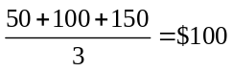 million
b. i. Empire building: value = 100 – 5 = $95 million
ii. Value = $100 million
iii. Empire building and increased risk: value = 0.5(50) + 0.1(100) + 0.4(150) – 5 = $90 million
iv. Increased risk: value = $95 million
c. Because the tax benefits are paid as a dividend, the manager will empire build or increase risk as determined in part (b). We can therefore determine the expected value with leverage by adding the expected tax benefit to the value calculated in part (b).
i. $95 + 10%(44) = $99.4 million
ii. $100 + 10%(49) = $104.9 million
iii. 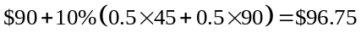million
iv. $95 + 10%(0.5 × 50 + 0.5 × 99) = $102.45 million
Therefore, $49 million in debt is optimal; even though there is a tax benefit, the firm’s optimal leverage is limited due to agency costs.
16-29. Which of the following industries have low optimal debt levels according to the trade-off theory? Which have high optimal levels of debt?
a. Tobacco firms
b. Accounting firms
c. Mature restaurant chains
d. Lumber companies
e. Cell phone manufacturers
a. Tobacco firms—high optimal debt level—high free cash flow, low growth opportunities
b. Accounting firms—low optimal debt level—high distress costs
c. Mature restaurant chains—high optimal debt level—stable cash flows, low growth, low distress costs
d. Lumber companies—high optimal debt level—stable cash flows, low growth, low distress costs
e. Cell phone manufacturers—low optimal debt level—high growth opportunities, high distress costs
16-30 According to the managerial entrenchment theory, managers choose capital structures so as to preserve their control of the firm. On the one hand, debt is costly for managers because they risk losing control in the event of default. On the other hand, if they do not take advantage of the tax shield provided by debt, they risk losing control through a hostile takeover.
Suppose a firm expects to generate free cash flows of $90 million per year, and the discount rate for these cash flows is 10%. The firm pays a tax rate of 40%. A raider is poised to take over the firm and finance it with $750 million in permanent debt. The raider will generate the same free cash flows, and the takeover attempt will be successful if the raider can offer a premium of 20% over the current value of the firm. According to the managerial entrenchment hypothesis, what level of permanent debt will the firm choose?
Unlevered Value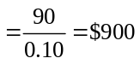.
Levered Value with Raider = 900 + 40%(750) = $1.2 billion
To prevent successful raid, current management must have a levered value of at least 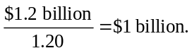
Thus, the minimum tax shield is $1 billion – 900 million = $100 million, which requires 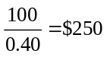 million in debt.
16-31. Info Systems Technology (IST) manufactures microprocessor chips for use in appliances and other applications. IST has no debt and 100 million shares outstanding. The correct price for these shares is either $14.50 or $12.50 per share. Investors view both possibilities as equally likely, so the shares currently trade for $13.50.
IST must raise $500 million to build a new production facility. Because the firm would suffer a large loss of both customers and engineering talent in the event of financial distress, managers believe that if IST borrows the $500 million, the present value of financial distress costs will exceed any tax benefits by $20 million. At the same time, because investors believe that managers know the correct share price, IST faces a lemons problem if it attempts to raise the $500 million by issuing equity.
a. Suppose that if IST issues equity, the share price will remain at $13.50. To maximize the long-term share price of the firm once its true value is known, would managers choose to issue equity or borrow the $500 million if
i. They know the correct value of the shares is $12.50?
ii. They know the correct value of the shares is $14.50?
b. Given your answer to part (a), what should investors conclude if IST issues equity? What will happen to the share price?
c. Given your answer to part (a), what should investors conclude if IST issues debt? What will happen to the share price in that case?
d. How would your answers change if there were no distress costs, but only tax benefits of leverage?
a. i. Borrowing has a net cost of $20 million, or 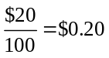 per share. Selling 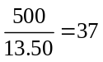 million shares at a premium of $1 per share has a benefit of $37 million, or 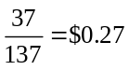 per share (i.e., 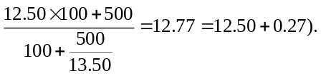 Therefore, issue equity.
ii. Borrowing has a net cost of $20 million, or per share. Selling million shares at a discount of $1 per share has a cost of $37 million, or per share. Therefore, issue debt.
b. If IST issues equity, investors would conclude IST is overpriced, and the share price would decline to $12.50.
c. If IST issues debt, investors would conclude IST is undervalued, and the share price would rise to $14.50.
d. If there are no costs from issuing debt, then equity is only issued if it is overpriced. But knowing this, investors would only buy equity at the lowest possible value for the firm. Because there would be no benefit to issuing equity, all firms would issue debt.
16-32. During the Internet boom of the late 1990s, the stock prices of many Internet firms soared to extreme heights. As CEO of such a firm, if you believed your stock was significantly overvalued, would using your stock to acquire non-Internet stocks be a wise idea, even if you had to pay a small premium over their fair market value to make the acquisition?
If the firm must pay 10% more than the target firm was worth, but can do the purchase using shares that were overvalued by more than 10%, in the long run the firm will gain from the acquisition.
16-33. “We R Toys” (WRT) is considering expanding into new geographic markets. The expansion will have the same business risk as WRT’s existing assets. The expansion will require an initial investment of $50 million and is expected to generate perpetual EBIT of $20 million per year. After the initial investment, future capital expenditures are expected to equal depreciation, and no further additions to net working capital are anticipated.
WRT’s existing capital structure is composed of $500 million in equity and $300 million in debt (market values), with 10 million equity shares outstanding. The unlevered cost of capital is 10%, and WRT’s debt is risk free with an interest rate of 4%. The corporate tax rate is 35%, and there are no personal taxes.
a. WRT initially proposes to fund the expansion by issuing equity. If investors were not expecting this expansion, and if they share WRT’s view of the expansion’s profitability, what will the share price be once the firm announces the expansion plan?
b. Suppose investors think that the EBIT from WRT’s expansion will be only $4 million. What will the share price be in this case? How many shares will the firm need to issue?
c. Suppose WRT issues equity as in part (b). Shortly after the issue, new information emerges that convinces investors that management was, in fact, correct regarding the cash flows from the expansion. What will the share price be now? Why does it differ from that found in part (a)?
d. Suppose WRT instead finances the expansion with a $50 million issue of permanent risk-free debt. If WRT undertakes the expansion using debt, what is its new share price once the new information comes out? Comparing your answer with that in part (c), what are the two advantages of debt financing in this case?
a. NPV of expansion 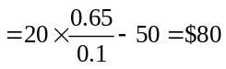 million
Equity value 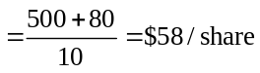
b. NPV of expansion 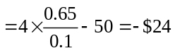 million share price 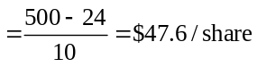
New shares 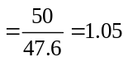 million shares
c. Share price 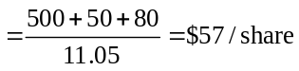
The share price is now lower than the answer from part (a), because in part (a), share price is fairly valued, while here shares issued in part (b) are undervalued. New shareholders’ gain of 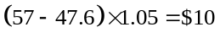 million = old shareholders’ loss of (58 – 57) × 10.
d. Tax shield = 35%(50) = $17.5 million
Share price 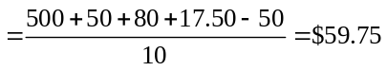 per share.
Gain of $2.75 per share compared to case (c). $1 = avoid issuing undervalued equity, and $1.75 from interest tax shield.

